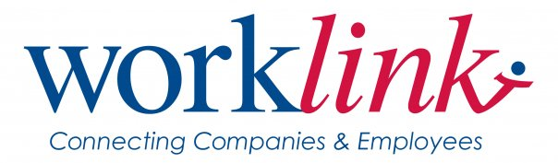
FINANCE COMMITTEE
Wednesday, October 5, 2011
3:00 P.M.
WorkLink Office

AGENDA

- Call to Order |  | David Collins
- Approval of July 27, 2011 Minutes | *
- Ratification of Email Votes  - AOP BIS Transportation  - Transfer Request | *
- PY’10 Budget Overview
  - ResCare
  - PYC
  - Overall

- PY’11 Budget Overview  - ResCare  - Carryover Budget Approval  - PYC  - Overall  - Budget Requests | *  *
- Other Business

- Adjournment

UPCOMING MEETINGS:
October 11, 2011 – Board Meeting – 1:00pm – TCTC

