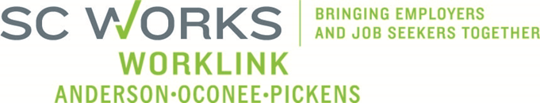

PY2013-2017 WorkLink Five-Year Local Plan
Directions for Public Comment
The WorkLink Workforce Investment Board is in the process of submitting its local plan, as required by the Workforce Investment Act (WIA) of 1998. Through this and other plans, WorkLink ensures the local workforce development system of Anderson, Oconee and Pickens Counties is market-driven and responsible in meeting the employment and training needs of businesses and job seekers.
An opportunity for public comment will be provided Monday, August 26, 2013 from 10:00am – 11:00am at the WorkLink office located in the SC Works Clemson Comprehensive Center at East Park at 1376 Tiger Blvd, Suite 102, Clemson, SC 29631.
Comments and questions regarding the WorkLink PY2013-2017 WorkLink Five-Year Local Plan may be sent to Ronnie Allen at rallen@worklinkweb.com. To obtain a copy of this document, visit: worklink.scworks.org.
WorkLink is an Equal Opportunity Employer/Program. Auxiliary aids and services are available upon request to individuals with disabilities.

