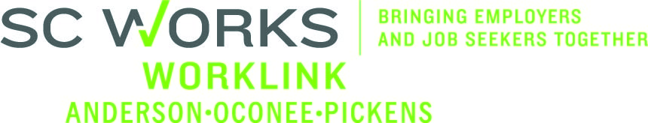

WORKFORCE INVESTMENT BOARD
Executive Committee
January 9, 2014 at 2:00 PM
SC Works Comprehensive Center Conference Room – Clemson, SC

AGENDA

- Call to Order Danny Brothers, Chair

- Approval of Minutes (10/30/13)* Danny Brothers

- Approval of WorkLink Region SC Works Operations Plan* Ronnie Allen

- SC Works Center Update Jennifer Kelly
- Center Traffic Flow, Services & other information

- Tabled Motion (10/30/13 Meeting) Danny Brothers

- Other Business Danny Brothers

Vision – To have a fully-employed, skilled workforce in Anderson, Oconee, and Pickens counties, SC
Mission – We develop the link between employers and the workforce in Anderson, Oconee, and Pickens counties, SC

Next Worklink Workforce Investment Board Meetings
February 12, 2014 at 1:00pm
Martin Inn & Conference Center
Lunch Immediately Precedes the Board Meeting

