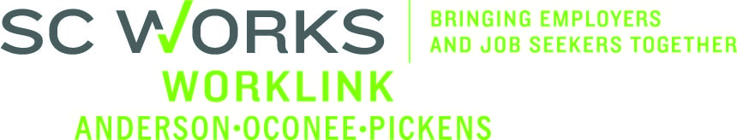

WORKFORCE INVESTMENT BOARD
Executive Committee
May 8, 2014 at 9:00 AM
SC Works Comprehensive Center Large Conference Room – Clemson, SC

AGENDA

- Call to Order Danny Brothers, Chair

- Approval of Minutes (01/09/14 & 04/10/14)* Danny Brothers

- DEW Proposal Discussion Round Table

- Executive Director Job Description & Posting Danny Brothers

- Other Business Danny Brothers
- Strategic Plan
- Budget Negotiations Update

Vision – To have a fully-employed, skilled workforce in Anderson, Oconee, and Pickens counties, SC
Mission – We develop the link between employers and the workforce in Anderson, Oconee, and Pickens counties, SC

Upcoming Meetings:

Executive Committee
May 28, 2014 at 2:00pm
SC Works Comprehensive Center Large Conference Room

Worklink Workforce Investment Board Meetings
June 11, 2014 at 1:00pm
Martin Inn & Conference Center
Lunch Immediately Precedes the Board Meeting

