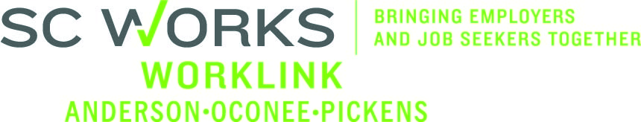

WORKFORCE INVESTMENT BOARD
Executive Committee
May 28, 2014 at 2:00 PM
Pendleton Library, Meeting Room – Pendleton, SC
AGENDA

- Call to Order Danny Brothers, Chair

- Approval of Minutes (05/08/14)* Danny Brothers

- DEW Proposal Update & Discussion Round Table

- PY’13 Budget Brandi Runion
- Henkels & McCoy PY’13 Grant Expenditure Review
- Henkels & McCoy PY’13 Grant Modification Request #4*

- PY’14 Budget Brandi Runion
- PY’14 Allocations from SCDEW
- PY’14 WorkLink In-House Budget Transfer Request (Transfer of 50% of Program DW Funds to Program Adult Funds)*
- PY’14 WorkLink In-House Budget Proposal*
- Henkels & McCoy PY’14 Adult/DW Grant*
- Henkels & McCoy PY’14 Youth Grant*

- WorkLink Office Water Damage Update Jennifer Kelly

- Executive Director Search Update Jennifer Kelly

- Other Business Danny Brothers

*Action Required

Vision – To have a fully-employed, skilled workforce in Anderson, Oconee, and Pickens counties, SC
Mission – We develop the link between employers and the workforce in Anderson, Oconee, and Pickens counties, SC

Upcoming Meetings:
Worklink Workforce Investment Board Meetings
June 11, 2014 at 1:00pm
Martin Inn & Conference Center
Lunch Immediately Precedes the Board Meeting

