Executive Committee Meeting
Agenda
September 30, 2014 – 10:00 AM
WorkLink Conference Room

- Welcome Danny Brothers, Chair

- Strategic Plan RFP* Danny Brothers

- WorkLink’s 501c3 Status Trent Acker

- 2015 Operator- Adult/DW RFP Update Trent Acker

- Resource Sharing Agreement (RSA) Update Trent Acker

- Unemployment Insurance Pilot Program Update Trent Acker

- Executive Session – Personnel Matter Danny Brothers

- Other Business Danny Brothers

- Adjourn Danny Brothers

An Equal Opportunity Employer/Program. Auxiliary aids and services are available upon request to individuals with disabilities.
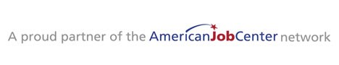

1376 Tiger Blvd Suite 102 Clemson SC 29631 P. 864.646.1515 F. 864.646.2814 Relay Service Dial 711 (TTY)

worklink.scworks.org

