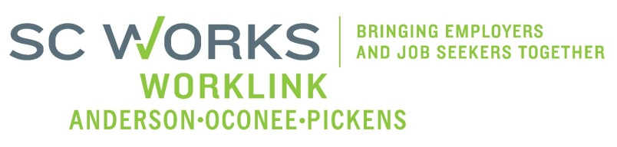

WORKFORCE INVESTMENT BOARD
YOUTH COUNCIL MEETING
AGENDA
Monday, January 12, 2015
11:00 A.M. - 12:30 P.M.

Wells Fargo - Meeting Room - 955 Tiger Blvd. Clemson, SC 29631
Park on the far right parking lot facing the building

- Welcome and Introductions Kristi King-Brock

- Approval of Minutes (10/6/14)* Kristi King-Brock

- Palmetto Youth Connections (Report) Karen Craven

- Old Business:
2014 AOP BIS Actual Award Paid Kristi King-Brock
2014 AOP BIS Final Update Rick Murphy
PY13 Final Grant Expenditures Brandi Runion
PY13 Final/Annual Youth Performance Sharon Crite

- New Business:
PY14 Grant Expenditures (8/26-12/2014) Brandi Runion
PYC PY14 Budget Modification* Brandi Runion/Kal Kunkel
2015 Youth Strategic Plan K. King-Brock
Youth, Education & Business Focus Group Questions/Response Donna Kazia, ACOG

- Other Business:
WIOA (Youth) Update - Information Kristi King-Brock
2015 Youth RFP Events & Dates - Information Kristi King-Brock

- Adjourn Kristi King-Brock

*Requires Vote

Next Youth Council Meeting, Monday - March 2, 2015 - 11:00am
Madren Center, Clemson University

