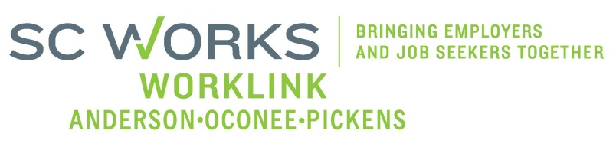

WORKFORCE INVESTMENT BOARD
YOUTH COUNCIL MEETING
AGENDA
Monday, January 14, 2013
10:00 A.M. - 1:00 P.M.

Board Room - Madren Center - Clemson University

- Welcome and Introductions Kristi King-Brock

- Approval of Minutes (10/01/12) Kristi King-Brock

- Palmetto Youth Connections (Report) Dana Grant

- National Adult Education Honor Society Dana Grant
- PY 12 Staff Restructuring Plan Dana Grant
- PYC Request for PY12 Budget Modification #3 Dana Grant

- New Business:
PYC Budget Mod. #3 /PY12 Grant Expenditures Brandi Runion PY11-Final/PY12-1st Qtr.Youth Performance Report Windy Graham
School District(s) Assessments (In-School Youth-PY13) King-Brock/ S.Crite
Youth Strategic Plan Committee Updates/Revisions Kristi King-Brock

- Next Meeting:
Guest Speaker Amanda Blanton-TCTC Kristi King-Brock
Invitation to Apprenticeship Carolina Kristi King-Brock

Adjourn Kristi King-Brock
Next Youth Council Meeting, March 4, 2013 - 11:00am
Madren Center, Clemson University

