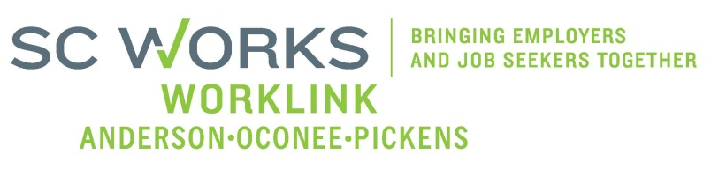

WORKFORCE INVESTMENT BOARD
YOUTH COUNCIL MEETING
AGENDA
Monday, October 1, 2012
11:00 A.M. - 12:00 P.M.

Board Room - Madren Center - Clemson University

- Welcome and Introductions Kristi King-Brock

- Approval of Minutes (8/06/12) Kristi King-Brock

- Palmetto Youth Connections (Report) Dana Grant

- Old Business
2010-2012 AOP BIS Transportation Expenses Brandi Runion
2012 AOP BIS Update/Introduction Rick Murphy
2012 AOP BIS Presentation R. Blackwell/R. Johnson
Youth Strategic Plan Sub-Comm.(s) Re-organization Kristi King-Brock

- New Business:
(1) Youth Council Resignation Kristi King-Brock
(1)Youth Council Membership Application Kristi King-Brock
PY 11 Final Youth Performance Report Windy Graham
PY 12 Negotiation of Youth Performance Goals Windy Graham
PY 11 Close Out/PY 12 Grant Expenditures Brandi Runion
2013 Youth Forum Discussion Kristi King-Brock

- Next Steps:
Youth Strategic Plan Review/Revision Kristi King-Brock

- Adjourn Kristi King-Brock
Next Youth Council Meeting, December 3, 2012 - 11:00am
Madren Center, Clemson University

