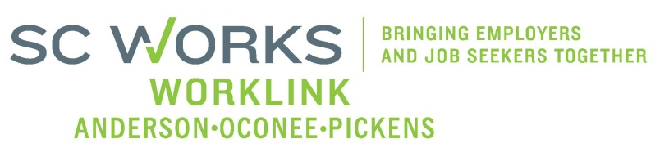

WORKFORCE INVESTMENT BOARD
YOUTH COUNCIL MEETING
AGENDA
Monday, March 02, 2015
11:00 A.M. - 12:30 P.M.

Board Room – Madren Center – Clemson University

- Welcome and Introductions Robert Halfacre

- Approval of Minutes (1/12/15)* Robert Halfacre

- Palmetto Youth Connections (Report) Karen Craven

- New Business:
Grant Expenditures (12/29-1/25/2015) Brandi Runion

- Old Business:
WIOA Committee(s) Restructuring Trent Acker
Youth, Educ.,& Bus.Focus Group Questions & Response Donna Kazia, ACOG
- Other Business:
Youth RFP Initial Committee Meeting 2/10/15 Robert Halfacre
2015 Youth RFP Released 2/13/15 Robert Halfacre

- Adjourn Robert Halfacre

*Requires Vote

Next Youth Council Meeting, Monday - May 14, 2015 - 11:00am
Madren Center, Clemson University

