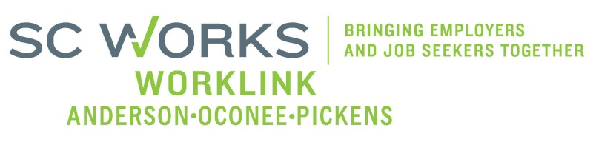

WORKFORCE INVESTMENT BOARD
YOUTH COUNCIL MEETING
AGENDA
Monday, May 04, 2015
11:00 A.M. - 12:15 P.M.

Board Room – Madren Center – Clemson University

- Welcome and Introductions Kristi King-Brock

- Approval of Minutes (3/2/2015)* Kristi King-Brock

- Palmetto Youth Connections (Report) Karen Craven
- PYC Transportation Revision effective July 1, 2015*
- Revised PYC Incentive Policy effective July 1,2015*
- Revise Marketing Items for WIOA*
- In-School Certification – Request Approval Under 5% Rule*

- New Business:
2014 AOP BIS Showcase Video Rick Murphy
2015 AOP BIS Showcase Funding* Kristi King-Brock
PY 14 1st & 2nd Quarter Youth Performance Sharon Crite
Grant Expenditures (1/26/15-3/22/15) Brandi Runion
PY 14 Youth Budget Mod #3* Brandi Runion
Request to Increase In-School Youth Stipend* Sharon Crite
Youth RFP Selected Bidder Kristi King-Brock
PY 15 RFP Youth Budget Negotiation Finalized* Brandi Runion

- Other Business:
PY 14 Youth Monitoring Report- Information Kristi King-Brock

- Adjourn Kristi King-Brock

*Requires Vote

Next Youth Council Meeting, Monday - August 3, 2015 - 11:00am
Madren Center, Clemson University

