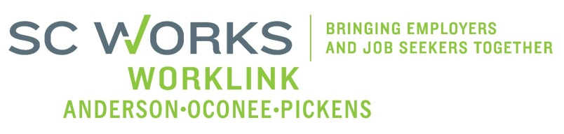

WORKFORCE INVESTMENT BOARD
YOUTH COUNCIL MEETING
AGENDA
Monday, May 5, 2014
11:00 A.M. - 12:00 P.M.

Board Room - Madren Center - Clemson University

- Welcome and Introductions Kristi King-Brock

- Approval of Minutes (3/3/14)* Kristi King-Brock
- Palmetto Youth Connections (Report) Karen Craven
  - PY 13 Youth Outreach Update Karen Craven
- New Business:
PY 13 Grant Expenditures (2/24/14-3/23/14) Brandi Runion
PY 13 2nd Quarter Youth Performance Report Sharon Crite
Youth Career Connect Grant Status (Anderson 3,4,& 5) Sharon Crite
Status of Option to Serve In-School Youth* Kristi King-Brock
PY 14 Youth Negotiation Team-Finalized Budget* Brandi Runion
(100% out-of-school youth)
Youth Waiver Requests from DOL* K.King-Brock/S.Crite

Next Meeting Explore & Discuss:
PY15 - RFP Direction - % of funds and available WIA services to meet identified needs of in-school youth in our community. Kristi King-Brock

Adjourn Kristi King-Brock
*Requires Vote

Next Youth Council Meeting, August 4, 2014 - 11:00am
Madren Center, Clemson University

