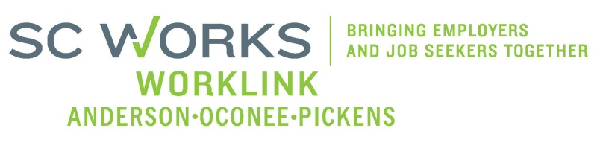

WORKFORCE INVESTMENT BOARD
YOUTH COUNCIL MEETING
AGENDA
Monday, May 07, 2013
11:00 A.M. - 12:15 P.M.

Board Room - Madren Center - Clemson University

- Welcome and Introductions Kristi King-Brock

- Approval of Minutes (3/04/13) Kristi King-Brock

- Palmetto Youth Connections (Report) Dana Grant

- Old Business:
Revised Youth Strategic Plan Kristi King-Brock
2013 Job Fair Update Brandi Runion
PY 13 Anticipated Youth Budget A & B Brandi Runion

- New Business:
Poverty Simulation Training Kristi King-Brock
2013 AOPBIS Event Rick Murphy
Youth Council Membership(s) Kristi King-Brock

- Other Business: Kristi King-Brock

Adjourn Kristi King-Brock

Next Youth Council Meeting, August 5, 2013 - 11:00am
Madren Center, Clemson University

