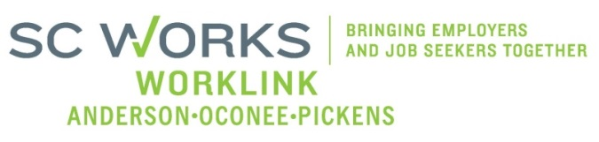

WORKFORCE INVESTMENT BOARD
YOUTH COUNCIL MEETING
AGENDA
Monday, August 5, 2013
11:00 A.M. - 12:00 P.M.

Board Room - Madren Center - Clemson University

- Welcome and Introductions Kristi King-Brock

- Approval of Minutes (5/07/13) Kristi King-Brock

- Palmetto Youth Connections (Report) Ann Marie Baker

- Old Business:
2013 AOPBIS Event Update Rick Murphy
2013 AOPBIS Anticipated Budget Brandi Runion
In-School WorkKeys Testing/Youth Incentive Funds B. Runion/S. Crite
PY13 Youth Negotiation Team-Finalized Youth Budget Brandi Runion
PY13 Youth Council Outreach Committee Kristi King-Brock

- New Business:
Youth Council Membership Applications Kristi King-Brock
PY 13 Youth Executive Summary Kristi King-Brock
Upcoming Youth Board Presentation (3 Segments) Sharon Crite
WIA Youth Suitability Checklist Sharon Crite
PY 13 Youth Performance Goals Negotiations Ronnie Allen/S. Crite
WorkLink New Business Service Model Ronnie Allen

- Other Business: Kristi King-Brock
Adjourn Kristi King-Brock

Next Youth Council Meeting, October 7, 2013 - 11:00am
Madren Center, Clemson University

