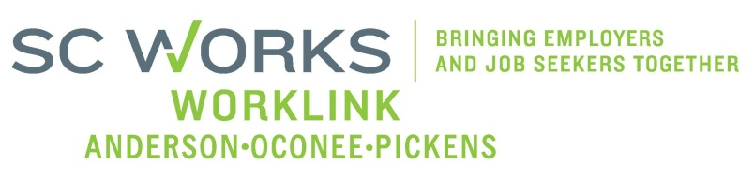

WORKFORCE DEVELOPMENT BOARD
Persons with Disabilities Committee AGENDA
SC Works Clemson Comprehensive Center at East Park
Thursday, August 11, 2016
3:00 – 4:00 pm

- Welcome and Introductions
- Approval of the May 12, 2016 Minutes*
- WorkLink’s Data
- Presentation by Steve Cook, SC Commission for the Blind
- Priority Populations Definitions
- Other Business
- Adjourn

*requires a vote

Next Persons with Disabilities Committee Meeting, Thursday, October 13, 2016 3:00 pm
SC Works Clemson Comprehensive Center

